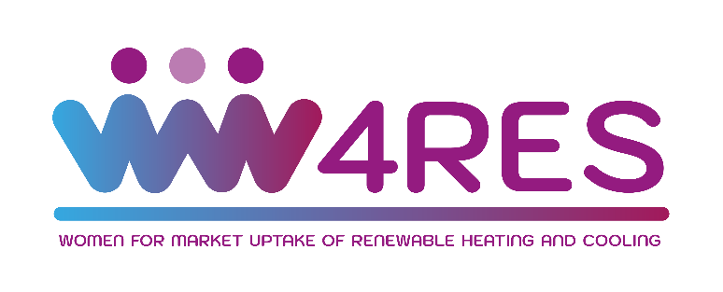
W4RES: Scaling-up the involvement of women in supporting and accelerating market uptake of renewable energy sources for heating and cooling

Call for Interest - Template for Application
The applicant will find the template online on the application area or will receive it from the Hub Manager in their country and need to fill in all the sections alone or with assistance of the Hub Manager.

Title of Proposal:
- Please indicate the title or name of your idea or project.

Evaluation Part 1 – Participant Information, Team Description & Leadership

List of participating organisation or persons
- Please list all participants and their organisation, as well as their roles and responsibility.
- In case there are more than 3 participants / organisations, please extend the list as needed.
No | Name of participant & organisation | Country | Please briefly describe your or your organisation’s specific expertise. | Type of organization, e.g. SME, large enterprise, university, R&I institute,
1
2
3

Team Description
- Describe your team and leadership incl. team members, their roles and responsibilities.

Max. ½ pages

Evaluation Part 2 – Problem & Innovation
- Explain the technical/economic/social problem that can be solved, or the business opportunity/product/service/solution that can be offered through your project.
- Please indicate how your project addresses the scope of the call topic through specific objectives that you expect to reach at the end of the project, which should be, measurable and achievable within the duration of the project.

Max. ½ pages

Evaluation Part 3 – Environmental & Technical Sustainability
- Please describe how sustainable and innovative technologies are used in your project to contribute to climate goals, e.g.
- through the sustainable reduction of greenhouse gas emissions
- a major increase in the use of renewable energies,
- much improved efficiency levels,
- or through addressing negative impacts of climate change.
- If available: Describe the technical specifications or developments in your project.

Max. ½ pages

Evaluation Part 4 – Business Case
- Please indicate roughly what kind of business model you foresee around your idea or project.
- Please describe the expected market applications, incl. quality of customer or user relationship and competitive advantage over existing solutions.
- Please list the targeted users of your solution: In which market segment or geographical areas do you see these potential users and how do you intend to reach them.
- Please explain how this idea or project is relevant or aligned to your organisation’s business strategy or development of your own expertise.

Max. ½ pages

Evaluation Part 5 – Other Impacts
- If available: Please describe further environmental, social or economic impacts outside of the RHC/energy sector, for example along the UN’s 17 Sustainable Development Goals (SDGs).

Max. ½ pages

Each applicant confirms:

● It is not under liquidation or is not an enterprise under difficulty accordingly to the
Commission Regulation No 651/2014, art. 2.18,
● Its Project is based on the original works and going forward any foreseen
developments are free from third party rights, or they are clearly stated,
● It is not excluded from the possibility of obtaining EU funding under the provisions of
both national and EU law, or by a decision of both national or EU authority,
- It has truthfully completed the information in the Application Form and accepts all statements embodied in the Terms of Reference, Consent Form and Privacy Policy, considering the ethical issues that might arise concerning the gathering of personal data, during the application process,
- It will participate in the services provided in case of award.

________________________ _________________________________________________

Place and Date of Signature Signature of the Participant/Organisation Representative

________________________ _________________________________________________

Place and Date of Signature Signature of the Participant/Organisation Representative

________________________ _________________________________________________

Place and Date of Signature Signature of the Participant/Organisation Representative
INFORMED CONSENT FORM

This consent form is to be filled and signed by each participating party.

Who we are:

We are PARTNER NAME and we are contacting you as Regional Hub Manager for COUNTRY NAME in the framework of W4RES a project funded by the European Union under the Horizon 2020 Framework Programme for Research and Innovation. A detailed description on how W4RES handles personal data is presented in the project’s Privacy Policy that accompanies this Consent Form.

Project: W4RES - Scaling-up the involvement of women in supporting and accelerating market uptake of renewable energy sources for heating and cooling (GA Number 952874).

Regional Hub Manager:
Partner name: Klicken oder tippen Sie hier, um Text einzugeben.
Address: Klicken oder tippen Sie hier, um Text einzugeben.
Phone: Klicken oder tippen Sie hier, um Text einzugeben.
E-mail: Klicken oder tippen Sie hier, um Text einzugeben.

Responsible persons:

# | Role | Name | E-mail
1 | W4RES Project Manager | Ioannis Konstas | konstas@qplan-intl.gr
2 | Regional Hub Manager | Klicken oder tippen Sie hier, um Text einzugeben. | Klicken oder tippen Sie hier, um Text einzugeben.
3 | Data Protection Officer | Klicken oder tippen Sie hier, um Text einzugeben. | Klicken oder tippen Sie hier, um Text einzugeben.

What do we offer you?
You have been nominated by a W4RES project partner in our region to become one of the 25 projects to receive business and technical support services for market uptake as well as support for gender mainstreaming and women's empowerment activities. These services will be carried out by W4RES experts.

The support services are expected to be delivered and last for approx. 2-6 months.
To effectively conduct this support services, we need to process some of your personal data:
- Your contact details (full name, email, phone number);
- Some basic demographics (age, gender);
- Your professional info (organization, job position, field of expertise);
- Your education info;
- Your opinions on the subject matter.
Why do we need your data & what will we do with them?
We need your data to contact you in order to plan and carry out the aforementioned business and technical support services and to resolve any ambiguities, questions and other issues that may arise after and as a result of the services received. We also need to record your data to keep track of the support service process. The project’s deliverables that will be derived by the support services will not include your personal data or any other information that could identify you. Your personal data will remain on our application documents.

We will share your data with a few other W4RES project partners that are also involved in this task and will participate in the drafting of the relevant deliverables and carry out the business and technical support services. We are also obliged to grant access to your data to:
- EU officials such as our Project Officer for purposes related to project’s evaluation;
- EU agencies and other authorities for project’s auditing purposes.
We would also be very happy if you gave us your consent to contact you in the future to ask you to participate in other project’s activities (e.g. surveys, interviews, W4RES Advisory Board, etc.) and also to inform you about the project’s progress (e.g. by sending you a newsletter or similar messages).
How can you withdraw your consent?
You should know that you can withdraw your consent at any time by communicating either on the phone or by email with the responsible persons listed in the previous page. With regards to the informational messages and newsletters you can always opt out by simply clicking the link ''Unsubscribe'' or something similar included at the end of all the relevant messages.
I hereby give my consent to the processing of my personal data needed for:
(Please, tick the boxes below to confirm that you give us your consent for the respective subject. Any boxes left unticked mean that you do not consent to the relevant subject.)

# | Consent Subject | Tick box
1 | My participation in the market uptake & capacity building services that will be carried out by W4RES | ☐
2 | Receiving newsletters and messages regarding W4RES activities | ☐

__________________________ ________________ ___________________________

Name Date Signature

A “project” can be a classic project in the sense of the word, an initiative or a business idea from any company, organisation or person.

